This is not just a hiking program,

this is a movement.

Open your heart and
lift your soul...

It is time to let go and release the things that have been a struggle or a burden. Movement reminds us that our bodies and minds are interconnected and gives us all a chance to harmonize with the earth and tap into balance within us. Mother Nature has an incredible influence on our lives. It is within nature that we can achieve real self-reflection, awareness and mindfulness. You can feel STRONG, LIBERATED, GROUNDED and EMPOWERED!
We start at the bottom of the trail, we all take a deep breath--the deepest one we have taken of the day--and clear out all that emotional clutter, all the resistance and self-limiting beliefs, and we choose to relax into the BEST version of ourselves. We have a goal to accomplish and that is to reach the top all while meeting some amazing women and being brave in exploration! Give yourself permission today to protect YOUR own personal time and space!
In this six week session of FYT, we will bond, meditate and connect with each other, all while getting stronger in our minds and bodies. I can't wait to see you there.
Much love,

Your Local Trail Leader

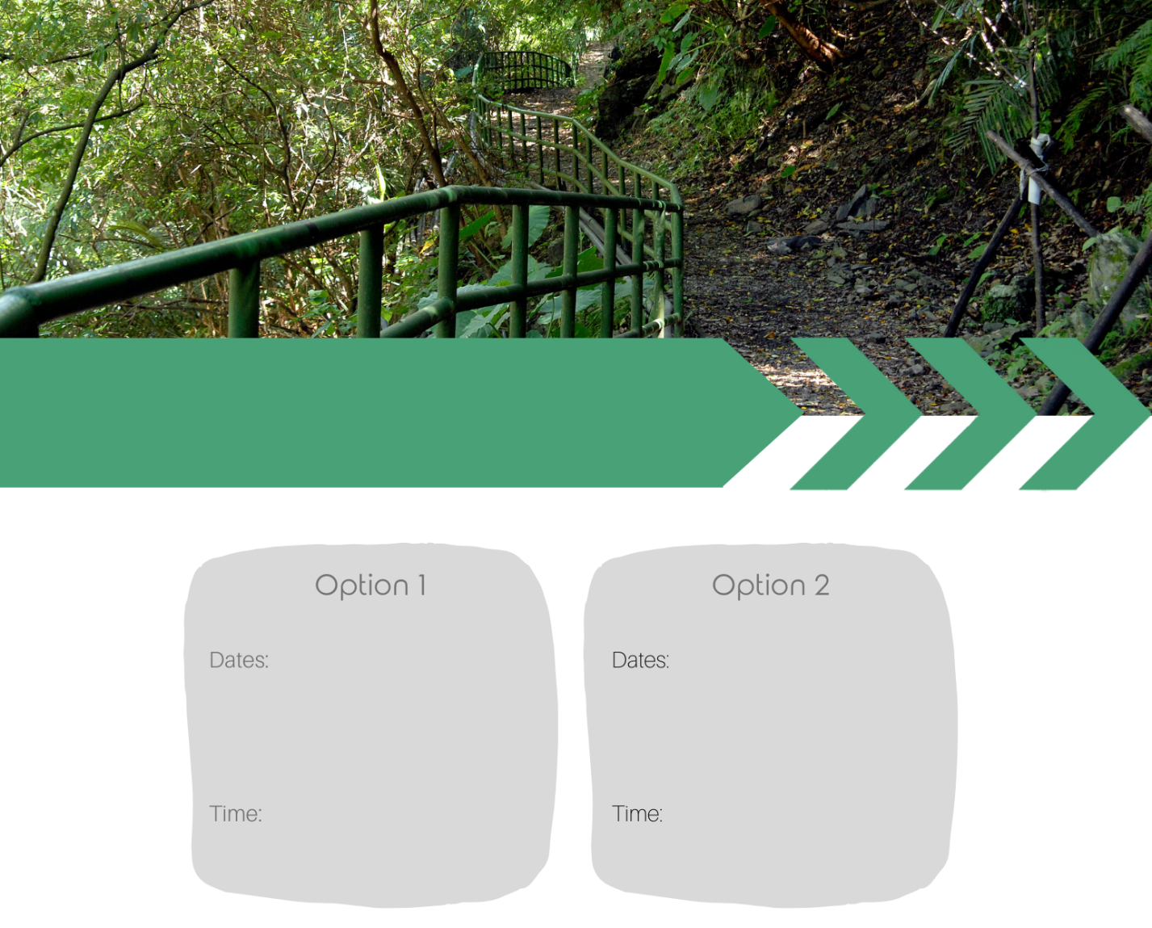

Choose Your Trail

Click here to add dates
Click here to add dates

Click here to add times
Click here to add times

Your investment: $XXX

LOCATION:

BOOKING:
My Name:
Email:
Phone:
Website:

CANCELLATIONS: If you cancel after the cut-off date and I am able to replace
your reservation with someone off the wait list, I will refund your deposit in full.

